## Sensorlist generated

The sensorlist has the same import result column. It also has the same fault codes as the devicelist. The only extra field that the sensorlist_generated has is the import result “New” in a green cell. This means that with the import of the sensorlist, you introduced a new i/o or control or that you changed something in the NavVision program itself which is much more likely. In Chapter 13 we will explain that these fields are of much importance to keep the sensorlist up to date. For now you must know what you are looking at when you open up the sensorlist_generated or the devicelist_generated. The sensorlist_generated is mostly much bigger than the devicelist_generated, so you can imagine that it will be a lot of work to keep the sensorlist up to date. See the next figure for a small excerpt of a devicelist_generated:

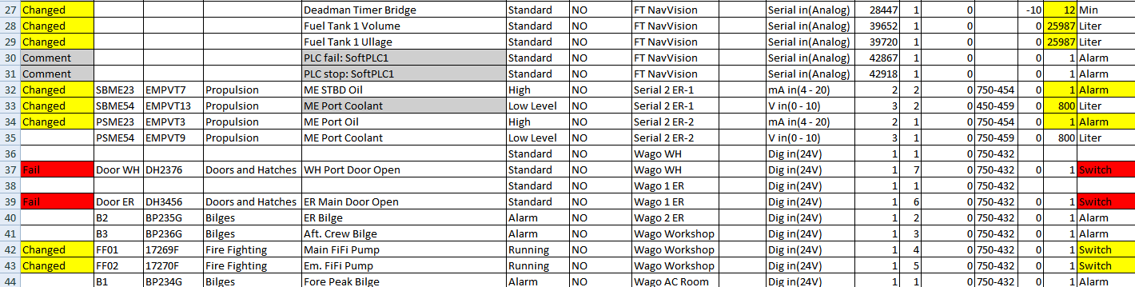

Figure 12‑7: sensorlist_generated